Distance and Displacement Worksheet Name:____________
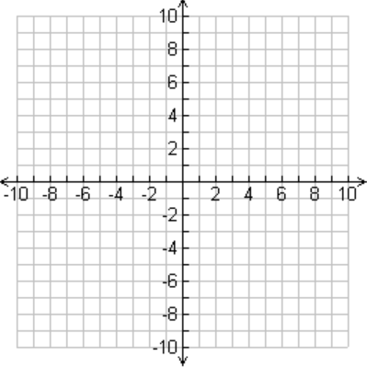
For each question plot the path on the grid paper.
- Joey drives his Skidoo 7 kilometres north. He stops for lunch and then drives 5 kilometres east. The entire trip took 30 min.
(a) What distance did he cover?

(b) What was his displacement?

(c) What was his average speed?

(d) What was his averagevelocity?

2. Neil skates to his science class. He travels 80 m east and then 40 m north in 100 secs.
(a) What distance did he cover?

(b) What was his displacement?

(c) What was his average speed?

(d) What was his average velocity?

